24-678: Computer Vision for Engineers

Ryan Wu

ID: weihuanw

PS6 Report

Due: Nov 10 2023

This file contains the following:

PS6-1 Part Identification and Classification

* all-parts-output.png
* readme.txt
* source code file(s) (attached to the end)

PS6-2 Detecting Defective Parts

* spade-terminal-output.png
* readme.txt
* source code file(s) (attached to the end)

**Findings and discussion:**

**PS6-1**

We are tasked to identify and label 5 types of mechanical parts: ring terminal, spade terminal, washer, internal lock washer, and external lock washer for this exercise. Some code was provided as the basic framework for parts detection.

The given code was missing the contour identification of internal lock washers and external look washers. To address this issue, I added two contour identification logic for specific part identification. For identifying internal lock washers, the program validates the contour having only the parent being circular and draws it in purple. For identifying external lock washers, the program validates the contour having the bounding box as square and draws it in yellow. I also increased the dilation iteration (4) to achieve better image results.

The results were satisfactory and the program was able to achieve the given tasks.

**PS6-2**

We are tasked to identify and label the defective spade terminal from the given image. The program first cleaned up the original image by performing erosion and dilation operations. To identify the defective spade terminal, I set the shape-matching threshold at 1.5 (higher is a stricter criterion for matching shapes) and labeled the defect in red. I also performed erosion and dilation operations to achieve better image results.

The results were satisfactory and the program was able to achieve the given tasks.

**PS6-1 all parts original & output image**



Figure 1. The given all parts image for part identification and classification.

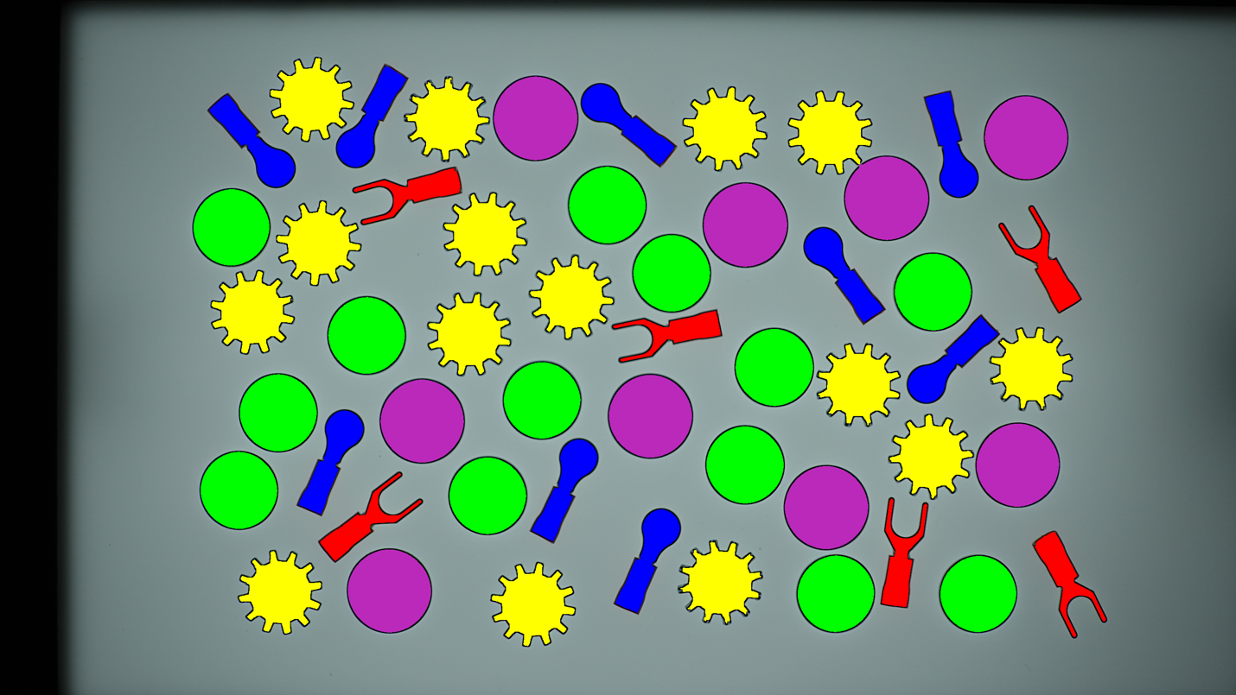

Figure 2. The output all parts image with different parts identified and color labeled.

**PS6-1 readme.txt**

24-678: Computer Vision for Engineers  
Ryan Wu  
ID: weihuanw  
PS6-1 Part Identification and Classification   
  
Operating system: macOS Ventura 13.5.2  
IDE you used to write and run your code: PyCharm 2023.1.4 (Community Edition)  
The number of hours you spent to finish this problem: 4 hours.

**PS6-2 spade terminal original & output image**

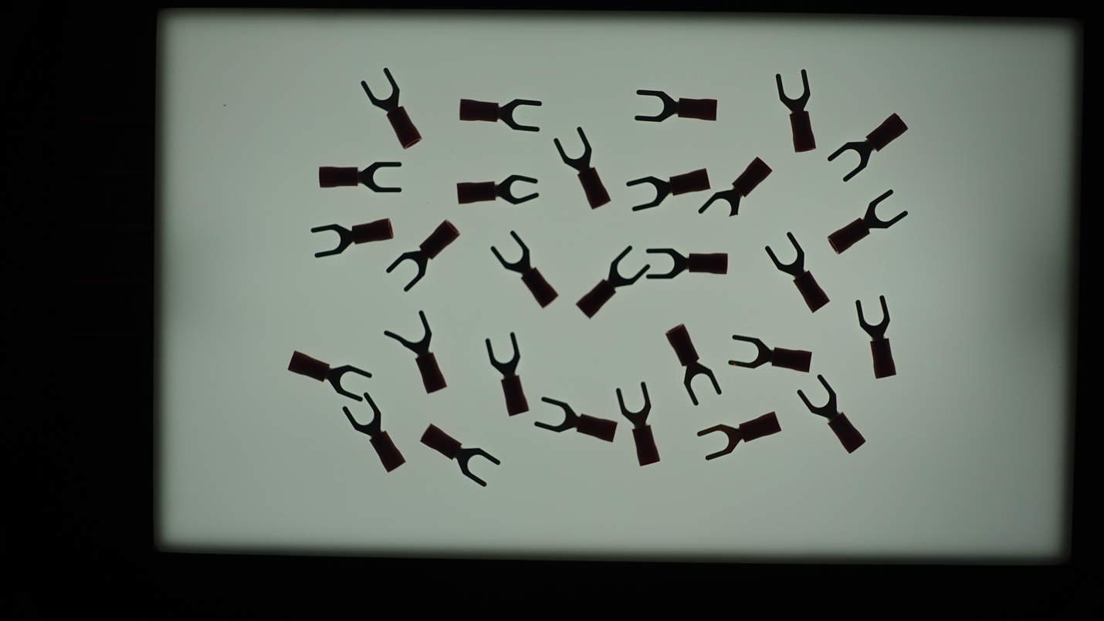

Figure 3. The given original image for defect detection.

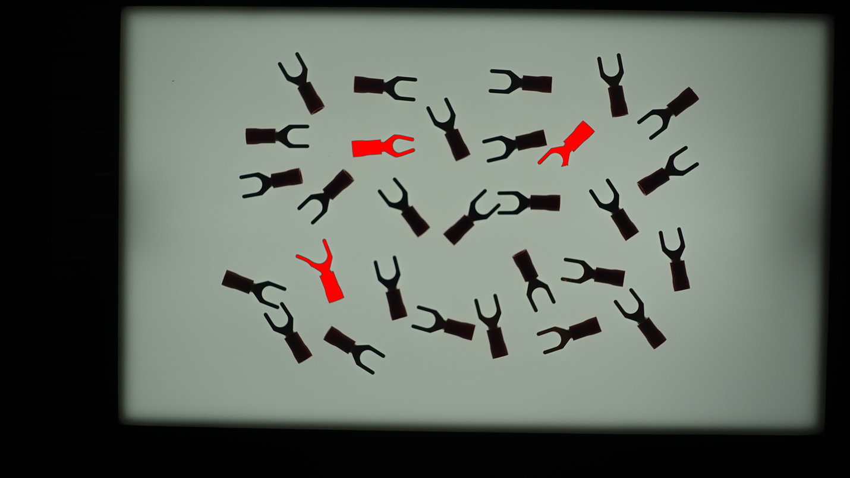

Figure 4. The output image with defects shown in red.

**PS6-2 readme.txt**

24-678: Computer Vision for Engineers  
Ryan Wu  
ID: weihuanw  
PS6-2 Detecting Defective Parts  
  
Operating system: macOS Ventura 13.5.2  
IDE you used to write and run your code: PyCharm 2023.1.4 (Community Edition)  
The number of hours you spent to finish this problem: 4 hours.